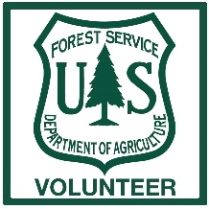
Willamette Trailwork Coordination Map
Viewers Guide
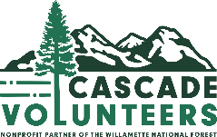
(as of 1/23/2022)
This map is intended to provide viewers with information about trail conditions
for the purpose of accomplishing trail work objectives.
To start, locate the map posted on cascadevols.org: https://cascadevols.org/trail-conditions/trail-work-coordination-map/
Direct link to the map: https://tinyurl.com/bdfm52ak
When viewing the map, all trails should show up as dotted lines. When these trails have colored lines next to them, that indicates that information is being shared about the section of trail that the line is drawn next to. When a trail has a star alongside it, that indicates a site-specific piece of information is being shared. Details about these features are below.

Line Features
These serve to demonstrate a trail condition from a certain point on the trail to another. Simply click the feature to view information about that section of trail.
(No Line Feature) If a trail in the background has no line feature next to it, that means we do not have updated information for that trail.
Scouted This indicates a section of trail has been scouted, and a scouting report should be included in the information tied to that feature.
Assigned – Brush Out This indicates a section of trail requires brush to be removed from the trail corridor, and that work has been assigned to a group. An estimated completion date will be included.
Assigned – Log Out This indicates a section of trail requires logs to be removed from the trail corridor, and that work has been assigned to a group. An estimated completion date will be included.
Brushed Out This indicates a certain section of trail has had brush removed by a certain group. A date of completion will be included.
Logged Out This indicates a certain section of trail has had brush removed by a certain group. A date of completion will be included. The “Logged Out” feature is generally used to show that a section of trail is now open to users, but exceptions exist. Look for other features along a trail to see if more work is planned.
Closure This indicates a certain section of trail is closed to public use until further notice.
Point Features
These serve to demonstrate where site-specific work is needed. Examples include building a retaining wall, restoring trail tread for X number of feet, installing X feet of puncheon, etc.
Unresolved This indicates a specific area where work is needed.
In Progress This indicates that work is in progress at the area indicated. An estimated completion date is included.
Resolved This indicates that work at the identified area has been completed.

